Damien Bafile

Design Document

Contents

Introduction 2

Specifications and Requirements 2

Application Design 2

INDEX.PHP 2

TOPTEN.PHP 3

LOGO.PHP 3

Navigation Hierarchy 3

Database Design 3

# Introduction

This is the design documentation for a web application that will be developed for SMT Movie Rental.

Specifications and Requirements

The website will be developed in PHP 7 with Microsoft Visual Studio Code© and the Webserver, PHP server and Database server will be provided by [XAMPP](https://www.apachefriends.org/index.html) Which includes Apache and MySQL. CSS will be provided by Bootstrap 4.

The Database is currently stored in a Microsoft Excel© spreadsheet it will be converted to a MySQL script with a free tool called [sqlizer.io/](https://sqlizer.io/). Then the script will be needed to be edited include a new column to store the data of the count searched movies entries and set the numbers to 0. Add a command to make ID field a Primary Key.

The Database is needed to be searchable by the following parameters

1. Title
2. Genre with Rating in Year
3. Title with genre

As movies are displayed by the server must increment the count and have a page to render an image with PHP GD functions.

# Application Design

## INDEX.PHP

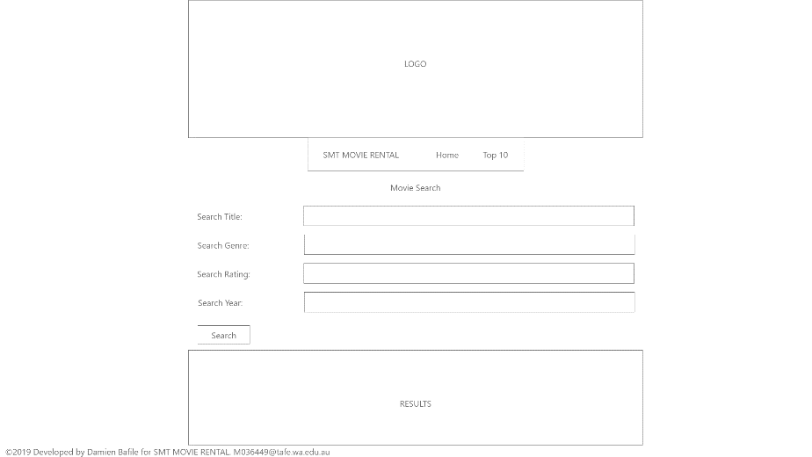

## TOPTEN.PHP

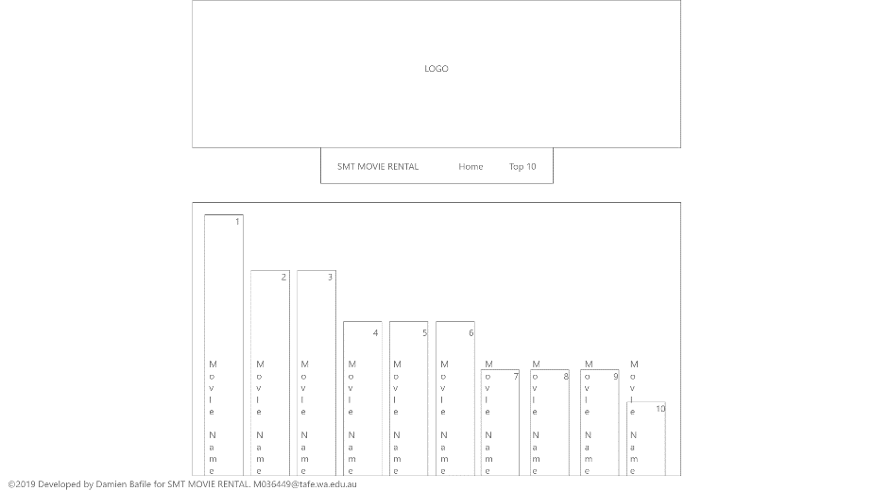

## LOGO.PHP



Navigation Hierarchy.

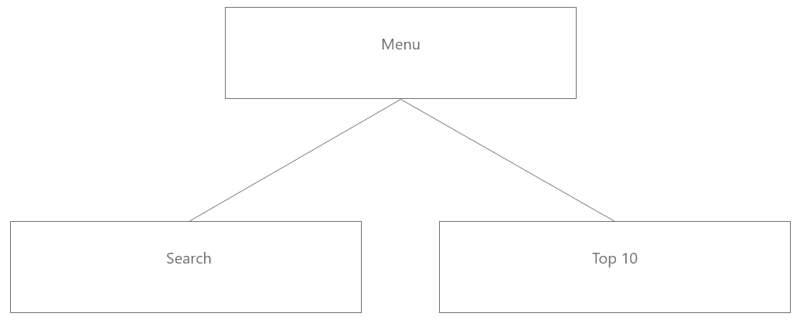

# Database Design

`ID` INT, Pir

`Title` VARCHAR(82) CHARACTER SET utf8,

`Studio` VARCHAR(15) CHARACTER SET utf8,

`Status` VARCHAR(12) CHARACTER SET utf8,

`Sound` VARCHAR(11) CHARACTER SET utf8,

`Versions` VARCHAR(18) CHARACTER SET utf8,

`RecRetPrice` NUMERIC(5, 2),

`Rating` VARCHAR(5) CHARACTER SET utf8,

`Year` INT,

`Genre` VARCHAR(17) CHARACTER SET utf8,

`Aspect` VARCHAR(6) CHARACTER SET utf8

`numbOfSearches` int;